STRUCTURED UNDERGRADUATE THESIS
MANUSCRIPT FORMAT AND ACADEMIC
WRITING TEMPLATE

Presented to the faculty of
College of Engineering and Architecture
CAGAYAN STATE UNIVERSITY
Carig, Campus
Tuguegarao City, Cagayan

In Partial Fulfillment
of the Requirements for the Degree
BACHELOR OF SCIENCE IN CIVIL ENGINEERING

GIVEN M. LAST NAME
GIVEN M. LAST NAME
GIVEN M. LAST NAME
GIVEN M. LAST NAME

April 2026

APPROVAL SHEET
This thesis titled “STRUCTURED UNDERGRADUATE THESIS MANUSCRIPT FORMAT AND ACADEMIC WRITING TEMPLATE”, prepared and submitted by GIVEN M. LAST NAME, GIVEN M. LAST NAME, GIVEN M. LAST NAME, and GIVEN M. LAST NAME in partial fulfilment of the requirements for the degree, Bachelor of Science in Civil Engineering major in Structural Engineering, is hereby recommended for final defense.

ENGR. GIVEN M. LAST NAME
Adviser

Approved by the Tribunal on Oral Examination with a grade of _______.

ENGR. GIVEN M. LAST NAME
Chairman

ENGR. GIVEN M. LAST NAME ENGR. GIVEN M. LAST NAME
Member Member

ENGR. GIVEN M. LAST NAME
Department Chair

Accepted and approved partial fulfillment of the requirements for the degree, Bachelor of Science in Civil Engineering major in Construction Engineering Management.

April 01, 2026 ENGR. GIVEN M. LAST NAME Date Dean, College

DEDICATION
This section is a personal note where the researcher dedicates the work to individuals or groups who provided inspiration, support, or motivation. It is usually written in a heartfelt and informal tone compared to the rest of the manuscript.

AUTHORS

Researchers

ACKNOWLEDGEMENT
This section expresses gratitude to those who contributed to the completion of the study. It can include advisers, faculty members, classmates, family, friends, and institutions. The tone is formal but appreciative.

TABLE OF CONTENTS
APPROVAL SHEET ii
DEDICATION iii
ACKNOWLEDGEMENT iv
TABLE OF CONTENTS v
LIST OF TABLES vii
LIST OF FIGURES viii
ABSTRACT ix
CHAPTER I 1
THE PROBLEM AND ITS BACKGROUND 1
1.1 Introduction 1
1.2 Statement of the Problem 1
1.3 Objective of the Study 1
1.4 Conceptual or Theoretical Framework of the Study 2
1.5 Significance of the Study 2
1.6 Scope and Delimitation 2
1.7 Definition of Terms 2
CHAPTER II 3
REVIEW OF RELATED LITERATURE 3
2.1. Introduction 3
2.2. Main Topic 3
2.3. International Perspective 3
2.4. National/Local Perspective 4
2.5. Synthesis 4
CHAPTER III 5
METHODOLOGY 5
3.1 General Overview 5
3.1 Study Area (if applicable) 5
3.2 Research Design 6
3.3 Materials, Instruments, or Respondents 7
3.4 Population and Sample 7
3.5 Research Instrument 8
3.6 Data Gathering Procedure 8
3.7 Reliability Test 8
3.8 Statistical Tools 9
3.9 Ethical Consideration 9
CHAPTER IV 10
RESULTS AND DISCUSSION 10
4.1 Introduction 10
4.2 Specific Objective 1 (Replace this heading with the descriptive title of your first objective, i.e., “Profile of the Respondents”) 10
4.3 Specific Objective 2 (Replace this heading with the descriptive title of your next objective, i.e., “Relationship Between Variables”) 10
CHAPTER V 11
CONCLUSION AND RECOMMENDATION 11
5.1 Summary 11
5.2 Conclusion 11
5.3 Recommendations 11
REFERENCES 12
APPENDICES 13
Appendix A. Guide to Appendices 13
Appendix B. Typical Appendix Contents 14

LIST OF TABLES
Table No. Title of Table Page
1 Distribution of Respondents by Sex 19

LIST OF FIGURES
Figure No. Title of Figure Page
1 Map of Cagayan State University Carig Campus 17

ABSTRACT
TITLE : STRUCTURED UNDERGRADUATE THESIS MANUSCRIPT FORMAT AND ACADEMIC WRITING TEMPLATE
RESEARCHER/S : FIRST M. LAST NAME
INSTITUTION : CAGAYAN STATE UNIVERSITY CARIG CAMPUS
DEGREE : BACHELOR OF SCIENCE IN CIVIL ENGINEERING
YEAR : 2026
ADVISER : ENGR. FIRST M. LAST NAME, PhD

The abstract should provide a concise yet comprehensive overview of the study, typically ranging from 150 to 300 words. It begins with a brief introduction that establishes the topic and explains its importance, giving readers immediate context for why the research matters. This is followed by a clear statement of the problem that identifies the central issue and highlights the research gap, pointing out what is lacking, unclear, problematic, or underexplored in existing literature or practice, and explaining how the study intends to address this gap. The abstract should then state the objectives of the study in one or two sentences, ensuring they are specific, measurable, and directly connected to the problem identified. After this, the methods are summarized by briefly describing the research design, participants, instruments, and procedures, with enough detail to show how the study was conducted but without unnecessary elaboration. The results are then presented in a straightforward sentence or two, emphasizing the most significant findings that directly relate to the objectives and provide evidence to answer the research questions. Finally, the abstract concludes with a sentence that ties the results back to the problem and research gap, showing how the study contributes new knowledge, insights, or practical applications, and indicating its broader implications. After the abstract, a list of 3 to 6 keywords should be added, arranged alphabetically or by relevance, to capture the main themes of the study and aid in indexing for future reference. If this template is not showing/downloaded properly, you may access the template at https://tinyurl.com/COEAManuscriptTemplate2.

Keywords: most; relevant; words

CHAPTER I

THE PROBLEM AND ITS BACKGROUND

1.1 Introduction
Bridges are critical components of transportation infrastructure, serving as lifelines for economic activity, emergency response, and regional connectivity. Ensuring their safety and long-term performance is essential, particularly in the Philippines, which is highly exposed to natural hazards such as earthquakes, typhoons, flooding, and soil erosion. These environmental and operational stresses accelerate structural deterioration, making continuous monitoring increasingly important.
This need is not merely theoretical for Region 2. Within the span of a single year, Cagayan Valley experienced two major bridge failures that exposed both the structural risks of relying on periodic inspection and the steep economic cost of losing a river crossing. On February 27, 2025, a span of the newly opened Cabagan–Sta. Maria Bridge in Isabela — a ₱1.2-billion, 990-meter structure connecting Cabagan and Sta. Maria — collapsed after an overloaded dump truck crossed it, injuring six people and severing a key route across the Cagayan River for nearly a year. Beyond the loss of a billion-peso public asset only weeks after its completion, residents reported reduced farm and business income during the closure, as produce had to be rerouted and local commerce lost access to a primary trade corridor. DPWH’s initial investigation attributed the failure to under-design, despite the bridge having been retrofitted only two years earlier.
Then, on October 6, 2025, the 45-year-old Piggatan Bridge in Alcala, Cagayan, gave way as multiple overloaded trucks carrying palay and corn crossed it during harvest season, injuring seven people and cutting off the route linking Alcala to Tuguegarao City and other Cagayan trading hubs. Local officials estimated that around 100,000 farmers in Alcala and neighboring towns depended on that crossing to move their produce, and with the detour stretching a ten-minute trip into an hour-long one, growers reported spoiled harvests and uncertain income even as they faced rising fuel and transport costs. Senate resolutions filed after both collapses explicitly cited significant economic losses alongside the casualties as justification for a nationwide inquiry into bridge safety, underscoring that structural failure in this region carries costs well beyond repair and reconstruction budgets — it disrupts entire agricultural supply chains and the livelihoods that depend on them.
These recent collapses have also raised concern over older structures still in daily use, chief among them the Buntun Bridge in Tuguegarao City. Opened in 1969 and stretching 1,369 meters across the Cagayan River, Buntun Bridge was for decades recognized as the longest river bridge in the Philippines — a title it held until the opening of the newer Camalaniugan Bridge in January 2026 — and it remains the sole direct connection between Tuguegarao City, Cagayan’s provincial capital, and Solana, as well as the broader route toward Isabela, Kalinga, and Apayao. After 56 years of continuous service, the bridge has shown clear signs of aging: engineers have documented fatigue in its steel truss members, and holes and cracks have repeatedly appeared in its concrete deck, prompting emergency repairs as early as 2023. In March 2025, weeks after the Cabagan–Sta. Maria collapse, DPWH imposed a 15-ton load restriction on Buntun Bridge in response to worsening structural conditions, barring trucks, trailers, and fully loaded buses. The bridge has also been temporarily closed outright during major flood events, including during Typhoon Uwan in November 2025 and Typhoon Tino shortly after, when rising Cagayan River water levels forced authorities to shut it down for hours at a time. Because Buntun Bridge is the only crossing linking Tuguegarao City to Solana and the towns beyond, each closure or restriction disrupts commuting, emergency response, and the movement of goods for the entire provincial capital, with logistics and delivery operations across the region affected until the bridge reopens. Given its critical role, its documented deterioration, and the load and weather-based restrictions already being managed reactively rather than through continuous data, Buntun Bridge presents both an urgent monitoring need and a practical, accessible site for testing a real-time frequency-based SHM system under real operating conditions.
Together, these incidents illustrate how deterioration and overloading can go undetected between visual inspections, and how the consequences — injuries, severed regional connectivity, and cascading economic losses to farmers, businesses, and commuters — fall directly on communities in Region 2. They underscore the urgency of a monitoring approach that can track a structure’s condition continuously rather than periodically, potentially flagging structural stress before it results in both human and economic loss.
Structural Health Monitoring (SHM) has emerged as a modern engineering approach for assessing the condition of structures through continuous or periodic measurement of structural responses. Among various SHM techniques, frequency-based monitoring is widely recognized as a reliable method for detecting structural changes. The natural and resonant frequencies of a structure are directly related to its mass and stiffness; therefore, any damage such as cracks, corrosion, or joint degradation can result in measurable shifts in frequency characteristics. In practice, vibration signals are acquired from the structure and processed to extract frequency information using techniques such as Fast Fourier Transform (FFT) and spectral analysis. These methods allow identification of dominant frequency components even in noisy environments, making them suitable for real-world applications.
Despite the effectiveness of frequency-based SHM, existing systems in the Philippines are largely dependent on imported technologies, including high-cost accelerometers, data acquisition systems, and proprietary software. These systems are often expensive and inaccessible for widespread deployment, limiting their use to large-scale infrastructure projects. As a result, many bridges — including those in Region 2 — rely primarily on periodic visual inspections, which, as the Cabagan–Sta. Maria, Piggatan, and Buntun Bridge cases demonstrate, may fail to detect early-stage structural deterioration or flag structures approaching their load limits before catastrophic failure occurs.
To address this gap, this study proposes the development of a localized, real-time frequency monitoring system for Structural Health Monitoring using MEMS-based Inertial Measurement Unit (IMU) sensors and an ESP32-S3 microcontroller. The system acquires vibration signals through MEMS IMUs, processes the data using FFT-based techniques, and extracts natural and resonant frequencies in real time. A web-based interface is also implemented for visualization and monitoring. The system is considered localized as it utilizes cost-efficient, locally accessible components and is designed to be adaptable to Philippine bridge conditions, and will be tested on Buntun Bridge in Tuguegarao City as a representative, high-criticality structure in Region 2. By focusing on affordability, portability, and real-time capability, the study aims to contribute to the development of practical SHM solutions for resource-limited environments — and to a monitoring approach that could have flagged the structural stress behind incidents like the Cabagan–Sta. Maria and Piggatan bridge collapses before they occurred.

1.2 Statement of the Problem
This study seeks to answer the following questions:
1. How can a real-time frequency monitoring system be developed to acquire and process structural vibration data?
2. How effectively can dominant structural frequencies be extracted from vibration signals under varying excitation and noise conditions?
3. How can the system provide real-time monitoring and visualization of structural vibration characteristics?

1.3 Objective of the Study
This study aims to develop a localized, real-time frequency monitoring system for bridge Structural Health Monitoring. Specifically, it aims to:
- Develop a real-time monitoring system capable of acquiring and processing structural vibration data.
- Extract and characterize dominant structural frequencies from acquired vibration signals under varying excitation conditions.
- Develop a real-time visualization interface for displaying structural vibration characteristics and frequency behavior.

1.4 Conceptual or Theoretical Framework of the Study
This study is grounded in the principle that a structure’s dynamic behavior — its natural and resonant frequencies — is directly governed by its mass and stiffness. Any change in a structure’s physical condition, such as cracking, corrosion, or joint degradation, alters its stiffness and therefore produces a measurable shift in these frequency characteristics. This relationship is the theoretical basis for frequency-based Structural Health Monitoring: by continuously observing a structure’s frequency behavior relative to its own established baseline, meaningful changes in structural condition can, in principle, be identified without requiring physical inspection.
The conceptual framework of the developed system follows an Input–Process–Output (IPO) model, illustrated in Figure 2.
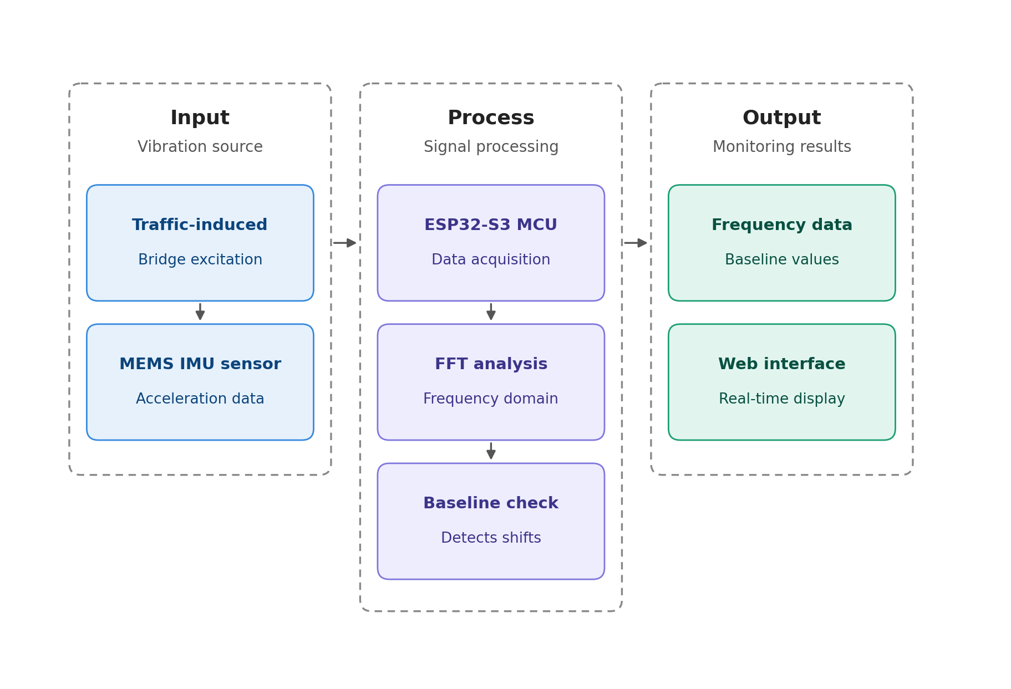
Figure 2. Input–Process–Output (IPO) Conceptual Framework of the SHM System
In the Input stage, vibration is generated by traffic-induced excitation as vehicles cross the bridge, and this vibration is captured as raw acceleration data by MEMS-based IMU sensors mounted on the structure.
In the Process stage, the ESP32-S3 microcontroller acquires and preprocesses the incoming sensor data, applies the Fast Fourier Transform to convert the signal from the time domain to the frequency domain, and compares the resulting dominant frequencies against the baseline frequency range established for the tested structure.
In the Output stage, the extracted frequency data and its relation to the baseline are transmitted to a web-based interface, providing real-time visualization of the structure’s vibration characteristics for monitoring purposes.
This framework positions the study’s contribution specifically within the Process and Output stages — developing the acquisition, frequency-extraction, and visualization pipeline — while the Input stage, the bridge structure’s actual vibration response, is the real-world phenomenon the system is designed to observe.

1.5 Significance of the Study
This study contributes to the development of a cost-effective and accessible Structural Health Monitoring solution for bridge infrastructure in the Philippines. By utilizing MEMS-based IMU sensors and an ESP32-S3 microcontroller, the system offers a practical, locally deployable alternative to the expensive imported SHM technologies that have limited continuous monitoring to only a small number of large-scale infrastructure projects.
To residents and commuters in Tuguegarao City and Solana, particularly those who rely on Buntun Bridge as their only direct crossing, this study represents a step toward monitoring the condition of a structure the community depends on daily for travel, trade, and emergency access — reducing reliance on reactive measures such as load restrictions and emergency closures imposed only after visible damage or a critical event occurs.
For engineers and infrastructure inspectors, the system offers a supplementary tool for continuous, real-time observation of structural vibration behavior, providing data between scheduled visual inspections rather than relying on inspection intervals alone.
For DPWH and other government agencies responsible for bridge maintenance, the system supports more informed, data-driven decisions on monitoring priorities and maintenance timing, offering a low-cost option that could extend structural oversight to bridges — especially aging or heavily trafficked ones like Buntun Bridge — that would otherwise go unmonitored between inspections.
For the local economy and communities in Region 2, including farmers, traders, and businesses whose livelihoods depend on uninterrupted access across the Cagayan River, this study supports the broader goal of reducing the risk of unplanned bridge closures and the trade, transport, and income disruptions that follow, as seen in the Cabagan–Sta. Maria and Piggatan Bridge incidents.
For the academic and engineering research community, this study contributes a documented reference for the development of embedded and IoT-based SHM systems using locally accessible components, offering a foundation that future researchers can build on — whether by extending the system to other structures, incorporating additional sensing modalities, or advancing it toward damage classification and predictive capabilities.
Ultimately, the localized design of this study promotes technological independence in structural monitoring and demonstrates that meaningful SHM capability can be achieved using affordable, readily available components — encouraging further innovation in this space within resource-limited settings.

1.6 Scope and Delimitation
This study focuses on the development and evaluation of a localized, frequency-based Structural Health Monitoring system for bridge structures. The system is designed to acquire vibration signals using MEMS-based IMU sensors, process the signals through FFT, and extract frequency characteristics for real-time monitoring. The hardware system utilizes an ESP32-S3 microcontroller for data acquisition and processing, and the extracted frequency data are transmitted to a web-based interface for real-time visualization.
The system will be tested on the Buntun Bridge in Tuguegarao City, Cagayan, as the representative structure for this study. Data collection is limited to this single bridge site; the system’s performance and extracted frequency characteristics are specific to Buntun Bridge and are not claimed to generalize to bridges of different structural types, spans, or material conditions without further testing.
Since no prior instrumented baseline exists for Buntun Bridge, this study establishes its baseline frequency ranges using the developed device itself, based on vibration data gathered under varying vehicular traffic conditions. The resulting baseline is therefore internal to the system and this deployment, and is not validated against an external reference sensor or a separately verified ground truth.
The study is limited to frequency-based monitoring and does not include structural diagnosis, damage classification, predictive modeling, load-capacity analysis, or repair recommendations. Interpretation of any observed frequency shift as a specific damage type or severity level is outside the scope of this study.
The system is further limited by hardware constraints such as processing speed, memory capacity, and sensor resolution. Environmental factors such as temperature, humidity, and electromagnetic interference are not fully incorporated into the analysis. Data collection is also limited to the specific time periods and traffic conditions observed during testing, and may not capture the full range of seasonal, weather-related, or long-term structural variation.

1.7 Definition of Terms
Baseline Frequency Range: The set of natural and resonant frequency values established for a specific structure under normal operating conditions, used as a reference point against which future vibration readings can be compared.
Excitation: An external force or disturbance, such as vehicular traffic, wind, or ambient vibration, that causes a structure to vibrate and produce a measurable dynamic response.
ESP32-S3: A microcontroller used for data acquisition, processing, and wireless communication in the system.
Fast Fourier Transform (FFT): A signal processing technique used to convert time-domain signals into frequency-domain data.
Frequency Monitoring: The process of analyzing vibration signals to extract frequency characteristics related to structural behavior.
Localized (System): In this study, refers to a system designed using cost-efficient, locally accessible components rather than imported, proprietary hardware, making it more feasible to deploy and maintain in resource-limited settings.
MEMS IMU (Micro-Electro-Mechanical Systems Inertial Measurement Unit): A sensor that measures acceleration and motion, used in this study for vibration data acquisition.
Natural Frequency: The inherent frequency at which a structure vibrates when disturbed, determined by its mass and stiffness.
Real-Time Monitoring: Continuous or near-instantaneous observation and processing of data.
Resonant Frequency: The frequency at which a structure experiences maximum vibration amplitude due to external excitation.
Structural Health Monitoring (SHM): A method of evaluating the condition of a structure through measurement and analysis of its response.
Vibration Signal: The raw time-domain data captured by the sensor, representing the structure’s motion or acceleration over time, prior to frequency-domain processing.

CHAPTER II

REVIEW OF RELATED LITERATURE
This chapter presents foreign and local literature, as well as related studies that provide context and support for the research.

2.1. Introduction
This section introduces the purpose of the Review of Related Literature. It explains that the chapter surveys existing works relevant to the study, including both international and local perspectives. While the subsections provided in this format (Main Topic, International Perspective, National/Local Perspective, and Synthesis) offer a clear structure, researchers are not required to follow this sequence strictly. They may organize the literature in a way that best presents their topic, whether by themes, chronology, variables, or perspectives, as long as the chapter concludes with a synthesis that integrates the reviewed works and connects them to the present study.

2.2. Main Topic
Discuss the central theme or subject of your study. Present relevant theories, concepts, or prior works that directly relate to your research focus. This section should establish the foundation for the perspectives that follow.

2.3. International Perspective
Summarize studies, articles, and literature from foreign or international sources. Highlight how global research has approached the topic, noting similarities, differences, or gaps that may be relevant to your study.

2.4. National/Local Perspective
Present literature and studies conducted within the country or local context. Emphasize findings that are specific to your region, community, or national setting, and explain how they connect to or differ from international perspectives

2.5. Synthesis
Conclude the chapter by integrating insights from both international and local literature. Point out common themes, contradictions, and gaps. Show how the reviewed works collectively justify the need for your study and how they lead toward your research objectives. The synthesis should clearly demonstrate the contribution your study intends to make.

CHAPTER III

METHODOLOGY
This chapter explains the methods and procedures used in the study. It must be documented clearly enough that another researcher could replicate the work. While the subsections below provide a suggested framework, students should adapt the methodology to their research type. Experimental, simulation, modeling, and design studies may require different emphases, and the order of subsections may vary. What matters is that the methodology is systematic, transparent, and replicable, with statistical tools and ethical considerations always included at the end.

3.1 General Overview
Provide a brief outline of the methodology. State the type of research (survey, experimental, simulation, modeling, design, qualitative, mixed methods, etc.) and explain why this approach is appropriate. This section sets the stage for the subsections that follow.

3.1 Study Area (if applicable)
For survey-type studies, describe the geographic or institutional setting where the survey was conducted. Include maps or contextual details if relevant. For experimental or simulation studies, this section may be omitted or replaced with a description of laboratory facilities or computational environments.
Figure 1 shows the map of Cagayan State University Carig Campus. All figures should be formatted with in-line wrapping, single spacing, and a caption placed directly below the figure as a stand-alone description.
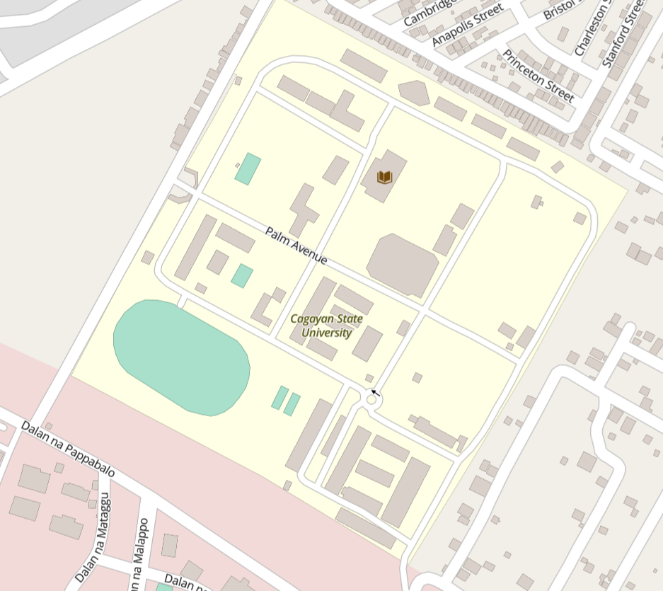
Figure 1. Map of Cagayan State University Carig Campus

3.2 Research Design
Explain the overall design of the study and justify why this design is appropriate. The methodology should highlight the specific aspects that are central to the chosen design. For survey-type studies, focus on the formulation of questions, respondent selection, and procedures for data collection. For experimental studies, emphasize materials selection, procurement, processing, design of experiments, and characterization techniques. For simulation studies, detail the algorithms, models, assumptions, and validation procedures. For modeling studies, concentrate on mathematical formulations, predictive structures, and verification steps. For qualitative studies, describe case selection, interview protocols, or thematic analysis procedures. For mixed-methods studies, explain how quantitative and qualitative approaches are integrated and how data from both are triangulated.

3.3 Materials, Instruments, or Respondents
This section should provide a clear description of the specific elements directly involved in the conduct of the study. The focus will vary depending on the research type, but the discussion must go beyond simple listing and instead explain how these elements contribute to achieving the objectives. For studies that involve physical experimentation, the methodology should detail the materials used, the instruments or equipment employed, and any relevant preparation or handling procedures. For studies that rely on computational or simulation approaches, the emphasis should be on the software platforms, datasets, or models applied, including any parameters or configurations that are critical to the analysis. For survey-based studies, this section should describe the respondents, their demographic or institutional characteristics, and the rationale for their inclusion.

3.4 Population and Sample
For survey-based studies, define the population and explain how the sample was selected. In other contexts, this may refer to the number of test specimens, trials, or simulation runs.
Table 1 presents the distribution of respondents by sex. Tables should be formatted with single spacing, captions placed above the table and presented as stand-alone descriptions.
Table 1. Distribution of Respondents by Sex*
SEX | RESPONDENTS | PERCENTAGE
Male | 12 | 40%
Female | 18 | 60%
Total | 30 | 100%
* Supporting notes can be included here.

3.5 Research Instrument
Describe the instruments used to collect data. For surveys, this may include questionnaires. For experiments, laboratory equipment. For simulations, software tools.

3.6 Data Gathering Procedure
Explain step by step how data were collected. For survey research, describe distribution and retrieval of questionnaires. For experimental research, detail preparation of materials, testing protocols, and measurement techniques. For simulation or modeling, describe input parameters, computational steps, and validation.

3.7 Reliability Test
Discuss how reliability of instruments or methods was tested. This may include calibration of equipment, repeatability of experiments, or consistency checks in surveys and simulations.

3.8 Statistical Tools
List and briefly explain the statistical tools used for data analysis. Common tools such as mean, standard deviation, t-tests, or ANOVA, need not have their formulas shown, since they are already well established. Equations should only be presented if they are central to the study, such as in modeling or specialized analysis.
Equation 1 illustrates the area of a circle, included here as an example of how equations should be formatted. Equations must be centered, numbered on the right, and followed by definitions of variables.
$$A=πr^{2}$$ | (1)

where $A$ is the area of the circle, $r$ is the radius of the circle and π is a constant, approximately 3.1416.

3.9 Ethical Consideration
State how ethical standards were observed, such as informed consent for surveys, confidentiality of data, safe handling of materials, and proper citation of sources.

CHAPTER IV

RESULTS AND DISCUSSION
This chapter presents the findings of the study and interprets them in relation to the objectives and literature reviewed. Results should be organized according to the research objectives, with each subsection presenting the findings and immediately discussing their meaning.

4.1 Introduction
Provide a brief overview of the chapter. State that results will be presented per objective and discussed considering related literature.

4.2 Specific Objective 1 (Replace this heading with the descriptive title of your first objective, i.e., “Profile of the Respondents”)
Present the results related to the first objective. Use tables, figures, or graphs where appropriate. Each table, figure, or equation must be referenced in the text, formatted consistently, and accompanied by a clear caption. Immediately follow with discussion that connects the findings to existing studies or theories

4.3 Specific Objective 2 (Replace this heading with the descriptive title of your next objective, i.e., “Relationship Between Variables”)
Present the results related to the second objective. Again, reference any supporting visuals or equations in the text, and provide interpretations that link the findings to the research problem and reviewed literature. Repeat subsections for additional objectives as needed, always pairing results with discussion.

CHAPTER V

CONCLUSION AND RECOMMENDATION
This chapter summarizes the study, presents conclusions based on the findings, and offers recommendations for practice, policy, or future research.

5.1 Summary
Provide a concise recap of the study’s purpose, methodology, and major findings. This should be written in paragraph form, not as bullet points.

5.2 Conclusion
State the conclusions drawn directly from the results. Each conclusion should clearly answer the research objectives. Avoid introducing new data here.

5.3 Recommendations
Offer practical or theoretical recommendations based on the conclusions. These may include suggestions for institutions, practitioners, policymakers, or future researchers. Recommendations should be specific, actionable, and logically derived from the findings.

REFERENCES
All sources cited in the manuscript must be listed in the References section, formatted according to APA style (7th edition). In-text citations should follow the author–date format, while the reference list must be arranged alphabetically by the first author’s surname, single-spaced, and formatted with a hanging indent. Journal titles are italicized, volume numbers included, and DOI links provided when available. Hypothetical examples are as follows (for template purposes only):
Dela Rosa, A. (2025, March 15). Local universities expand sustainability initiatives. The Philippine Daily Chronicle. https://www.philchronicle.ph/news/sustainability-initiatives
GreenFuture Organization. (2025). Climate action projects in Southeast Asia. Retrieved February 10, 2026, from https://www.greenfuture.org/projects
Lopez, F. G. (2021). Assessing water management practices in rural communities (Unpublished undergraduate thesis). Cagayan State University, Carig Campus.
Ramirez, J. P. (2022). Foundations of research methodology: A practical guide (2nd ed.). Manila Academic Press.
Santos, R. L., & Cruz, M. T. (2024). Renewable energy adoption in urban communities: A comparative study. Journal of Sustainable Development Studies, 18(2), 45–62. https://doi.org/10.1234/jsds.2024.5678
Villanueva, K. M. (2023). Smart building technologies for tropical climates. In Proceedings of the International Conference on Sustainable Engineering (pp. 112–120). Singapore Institute of Technology.

APPENDICES

Appendix A. Guide to Appendices
The appendices provide supplementary material that supports the study but is too detailed or lengthy to include in the main text. Each appendix should be labeled clearly, using the format “Appendix A. Title/Description” or “Appendix B. Title/Description”, with the content following immediately after the label and title. Appendices must be referenced in the body of the manuscript where relevant, and they should contain materials such as survey instruments, raw data tables, sample calculations, extended descriptions of procedures, or supplementary figures and diagrams.
Figures, tables, and equations included in the appendices must have numbering that is separate from the main text. To distinguish them, use the appendix letter as a prefix. For example, figures in Appendix A should be labeled as Figure A1, Figure A2, and so on, while tables should be labeled as Table A1, Table A2, and equations as (A1), (A2). In Appendix B, numbering would continue as Figure B1, Table B1, and (B1), respectively.

Appendix B. Typical Appendix Contents
Typical contents for the appendices may include:
- Copies of survey questionnaires or interview guides
- Raw data tables or extended datasets
- Sample calculations or derivations
- Detailed descriptions of instruments or procedures
- Additional figures, charts, or diagrams not central to the main discussion
Appendices should be formatted consistently, with clear titles and stand-alone descriptions. They serve as supporting evidence and documentation, ensuring transparency and replicability without interrupting the flow of the main chapters.

